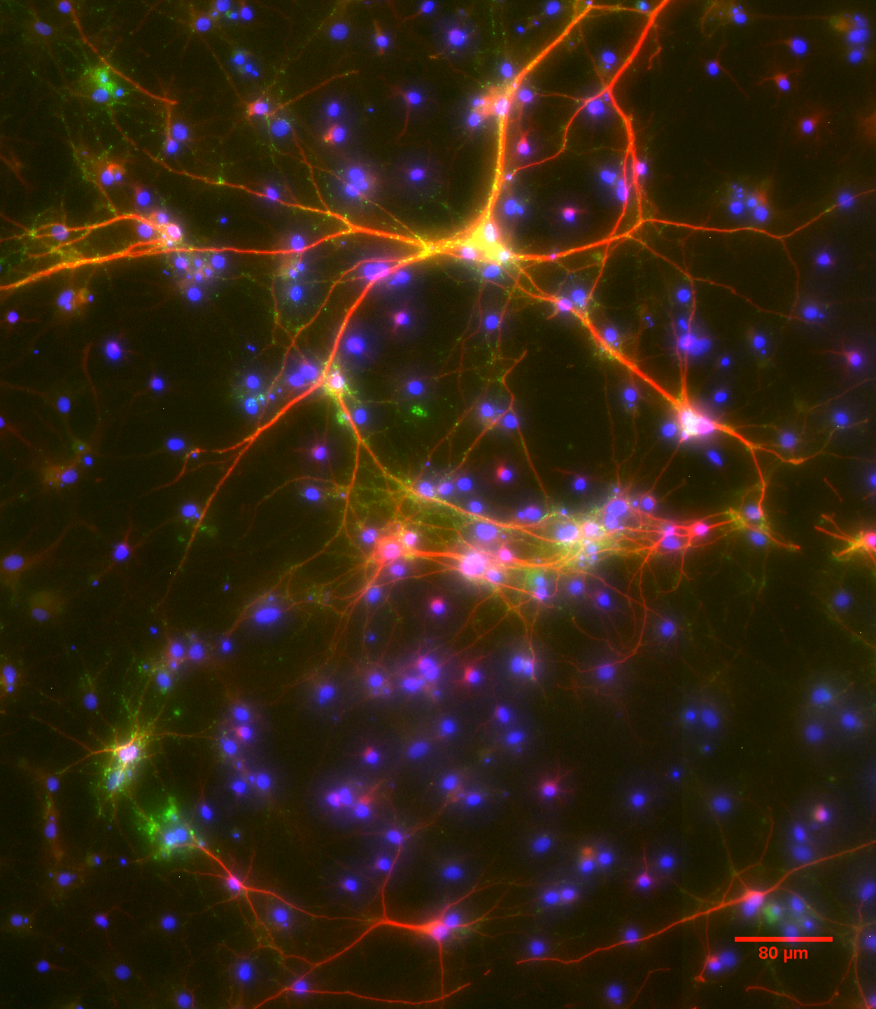
Figure 1. Picture of a 14 day old in vitro culture of rat brain cell (Cortical neuron) obtained from a one-day-old newborn Wistar rat showing effects of nitric oxide on neurotransmission.
The above is a control image showing distribution of synaptophysin in cortical neurons
Dendritic marker Map 2 staining; RED, Synaptic protein synaptophysin; GREEN and Hoechst stain for cells; BLUE

Figure 2. Concentration-Effect study of High concentration of DETA-NONOate (1-250µM) on cell survival.
DETA-NONOate is a nitric oxide (NO) donor. The above figure shows that at 250µM DETA-NONOate there was no cell alive due to the increase in concentration of NO at a non-physiological amount. This study was carried out to further establish the point that NO affects neuritic growth and synapse formation. There was however an obvious difference among the various concentrations studied. With a P value of 0.0020(**), N=3, One-way ANOVA the difference was significant. A further Tukey test as always showed that this difference arose between the groups.

